
INTEGRATED REINFORCEMENT LEARNING FRAMEWORK
FOR AUTONOMOUS ROBOT NAVIGATION AND ADAPTATION
ASSIGNMENT PROBLEM REPORT
Submitted in the partial fulfilment for the Course of
MLA0303 – REINFORCEMENT LEARNING
to the award of the degree of BACHELOR OF TECHNOLOGY IN
AI & ML
Submitted by
R. Geethika (192425101)
Faculty Name
D. Prasanth

SIMATS ENGINEERING
Saveetha Institute of Medical and Technical Sciences Chennai-602105
August 2026

Integrated Reinforcement Learning Framework for Autonomous Robot Navigation and Adaptation
Reinforcement Learning — Course Assignment Report

A. Assignment Information
Department | B.Tech AI&ML
Programme | B.Tech
Course Code & Name | [MLA0303] – Reinforcement Learning
Academic Year / Batch | 2026–24
Faculty Name | [D. Prasanth]
Assignment Title | Integrated RL Solution for Autonomous Robot Navigation and Adaptation
Date of Issue | [01/09/2026]
Date of Submission | [03/09/2026]
Maximum Marks | 100
Team Size | [3] members

Team Members:
R. Thanvitha Reddy (192425068— Policy-Based RL & Low-Level Control
R. Geethika (192425101) — Model-Based RL & Environment Prediction
D. Hasini (192425147) — Hierarchical RL & Route Planning, Meta-Learning, Evaluation & Report Compilation

1. Problem Statement and Problem Formulation
Suggested well-scoped problem statement (edit freely to match your simulator/tools):
A mobile robot operating in a dynamic, partially observable environment must simultaneously (a) learn effective control policies for locomotion and obstacle avoidance, (b) anticipate how the environment will change (moving obstacles, shifting layouts, sensor drift), (c) plan multi-step routes toward distant goals rather than react greedily, and (d) adapt within a handful of episodes when placed in a previously unseen environment configuration. No single reinforcement-learning paradigm addresses all four needs well: pure policy-based methods are sample-inefficient and re-optimise from scratch in new settings; pure model-based methods struggle with long-horizon credit assignment; flat policies do not scale to long, structured tasks; and standard RL has no mechanism for rapid adaptation. This project designs, implements and evaluates an integrated RL framework that combines policy-based RL (for low-level continuous control), model-based RL (for environment/dynamics prediction and route planning), hierarchical RL (for temporal abstraction between route-level and control-level decisions) and meta-learning (for fast adaptation to novel environment instances), and evaluates the combined system in a simulated navigation environment against ablated baselines.

Stakeholders
- Robotics engineers and researchers building autonomous navigation systems
- Operators of warehouse, logistics, service or inspection robots
- End-users and bystanders who share space with the robot
- Safety and regulatory bodies overseeing autonomous mobile robots

Expected Outcomes
- A trained hierarchical agent integrating the four RL paradigms into one pipeline
- Demonstrated few-shot adaptation to unseen environment layouts/dynamics
- Quantitative comparison of sample efficiency, adaptation speed and navigation success rate against non-integrated baselines
- A working navigation demo: new environment → short adaptation phase → successful route execution

Data, Task Distribution and Metadata
- Environment: a configurable simulator (e.g., a custom 2D/3D gridworld, Gazebo, AI2-THOR or Habitat) exposing a distribution of “tasks” — variations in obstacle layout, floor friction, sensor noise and goal location
- Trajectories: state–action–reward–next-state tuples logged per episode, tagged with the task/environment identifier they came from
- Metadata to document: state/action space dimensionality, number of distinct training tasks vs. held-out test tasks, episode length distribution

Assumptions
- A simulator is available and can be re-parameterised programmatically to generate many distinct “tasks” for meta-learning
- The robot's state is observable through a fixed sensor suite (e.g., LIDAR ranges, pose, local occupancy grid), possibly with noise
- Available compute is a single GPU/workstation-class environment, not a distributed training cluster
- Safety-critical real-world deployment is out of scope; this is a simulation-based feasibility study

2. Objective and Expected Outcomes
- Design an integrated architecture combining policy-based RL, model-based RL, hierarchical RL and meta-learning
- Train a low-level, policy-based controller for continuous locomotion and obstacle avoidance
- Train a model-based module that predicts environmental dynamics and is used for route planning
- Design a hierarchical manager–worker structure that separates route-level decisions from control-level actions
- Apply meta-learning so the agent adapts to a new environment instance within a small number of episodes
- Evaluate sample efficiency, adaptation speed and navigation success rate, and compare against flat/non-adaptive baselines
- Reflect on the safety and ethical implications of autonomous decision-making during exploration and adaptation

3. Requirements, Constraints and Assumptions

Functional Requirements
- Configurable environment/task simulator with a distribution of training and held-out test tasks
- Policy-based low-level controller (continuous or discretised action space)
- Learned dynamics/reward model for environment prediction and planning
- Hierarchical manager–worker policy structure (sub-goal selection + sub-goal execution)
- Meta-learning loop that produces an initialisation/adaptation procedure usable within a few episodes
- Evaluation pipeline reporting return, success rate, sample efficiency and adaptation curves

Performance Requirements
- Stable training across all four components (converging losses/returns, no divergence)
- Adaptation to a new task within a small, pre-specified episode/gradient-step budget
- Control-loop inference fast enough for near-real-time simulated operation

Data Requirements
- A documented task distribution with a clear train/held-out split so adaptation is evaluated on genuinely unseen configurations
- No leakage of test-task-specific tuning into meta-training

Technical Constraints
- Approved framework: PyTorch (optionally with Stable-Baselines3 / a custom actor-critic implementation)
- Modular, maintainable code: separate environment/task sampler, policy network, dynamics model, hierarchical controller and meta-learning loop

Model Requirements
- Actor-critic network for the policy-based controller (e.g., PPO or SAC)
- Feed-forward or recurrent dynamics model predicting next state and reward
- Manager network outputting sub-goals/options on a slower timescale than the worker policy
- Meta-learner: gradient-based (MAML-style) or context-based (recurrent, RL²-style) adaptation mechanism

Reliability
- Fixed random seeds where possible for reproducibility across runs
- Strict separation of meta-train and meta-test task sets; save trained weights and adaptation logs

User Requirements
- A simple demo (script or notebook) showing: new environment instance → adaptation phase → final navigation trajectory

Cost and Time
- Deliverable within academic computing resources and the submission deadline

Ethical and Societal Considerations
- Exploration during meta-adaptation could produce unsafe actions in a real deployment; simulation-only exploration is required unless safety constraints are added
- The system should support, not replace, human oversight, especially during the adaptation phase in a new environment

4. Application of Relevant Course Knowledge / Concepts
Explain, in your own words, how each concept below is used in your specific implementation:
- Markov Decision Process (MDP) formulation: state, action, reward and transition definitions for the navigation task
- Policy gradient theorem and actor-critic methods; the clipped surrogate objective in PPO or the entropy-regularised objective in SAC, and why one is chosen for continuous control
- Model-based RL: learning a transition/reward model and using it either for planning (e.g., Model Predictive Control) or for generating synthetic rollouts (Dyna-style) to improve sample efficiency
- Hierarchical RL: the options/semi-MDP framework or feudal/goal-conditioned architectures, and how temporal abstraction shortens the effective horizon for both learning and adaptation
- Meta-learning: gradient-based meta-learning (MAML) that finds an initialisation adaptable in a few gradient steps, versus context-based meta-RL (RL²) that adapts implicitly via a recurrent policy conditioned on recent experience
- Exploration–exploitation trade-off, and how it changes during meta-adaptation on a new task versus during meta-training
- Credit assignment over long horizons, and how hierarchical decomposition and the learned model both help address it
Include at least one worked calculation — e.g., a discounted-return / Generalized Advantage Estimation (GAE) computation for a short trajectory, or the parameter count of the policy network.
Worked example (GAE for a 3-step trajectory, γ = 0.99, λ = 0.95):
Rewards: r₁ = 1, r₂ = 1, r₃ = 5 (goal reached). Value estimates: V(s₁) = 3.0, V(s₂) = 3.5, V(s₃) = 4.0, V(s₄) = 0 (terminal).
TD residuals: δ_t = r_t + γ·V(s_{t+1}) − V(s_t)
δ₁ = 1 + 0.99(3.5) − 3.0 = 1.465 δ₂ = 1 + 0.99(4.0) − 3.5 = 1.460 δ₃ = 5 + 0.99(0) − 4.0 = 1.000
GAE advantage: A_t = Σ (γλ)^k δ_{t+k}. For t = 1: A₁ = δ₁ + (γλ)δ₂ + (γλ)²δ₃ = 1.465 + 0.9405(1.460) + 0.8845(1.000) ≈ 3.29, giving the advantage used to update the actor at step 1.
Worked example (parameter count of a small manager network):
A manager MLP mapping a 20-dimensional state to 8 candidate sub-goals through one hidden layer of 64 units has: input→ hidden = (20 + 1) × 64 = 1,344 parameters; hidden→ output = (64 + 1) × 8 = 520 parameters; total = 1,864 parameters.

5. Design / Proposed Solution / Methodology

5.1 End-to-End System Architecture
Sensors (LIDAR / pose / local occupancy grid) → State Encoder → High-Level Manager Policy (hierarchical RL: selects a sub-goal / option on a slower timescale) → Low-Level Policy-Based Controller (PPO/SAC: executes primitive actions to reach the sub-goal) → Environment; in parallel, a Model-Based Predictor forecasts future states/rewards and is used for route planning and for detecting environmental change; a Meta-Learning outer loop trains the manager, controller and predictor across a distribution of task instances so that, at deployment, a handful of episodes of experience in a new instance is enough to adapt all three → Adapted Agent → Evaluation / Demo Output.

5.2 Task / Environment Pipeline
- Source: a configurable simulator exposing parameters such as obstacle layout, friction, sensor noise and goal position, used to sample a distribution of training tasks and a disjoint set of held-out test tasks
- Split: e.g., 80% of sampled task configurations for meta-training, 20% held out for meta-testing/adaptation evaluation
- Preprocessing: state normalisation, frame/observation stacking where useful for partial observability
- Task sampling (train only): randomise layout, dynamics and noise parameters each meta-training iteration so the agent is trained across variation, not on a single fixed map

5.3 Component Architectures (baseline — adjust to your experiments)
Policy-based low-level controller:
- Actor: MLP(state → 64 → 64 → action) with tanh-squashed Gaussian output (continuous control) trained with PPO (clipped objective) or SAC (entropy-regularised)
- Critic: MLP(state → 64 → 64 → 1) estimating the value function, trained jointly with the actor
Model-based predictor:
- Dynamics model: MLP or small recurrent network mapping (state, action) → predicted next state and reward
- Used either for Model Predictive Control (short-horizon rollout search over candidate action sequences to choose a route) or as a Dyna-style source of synthetic transitions to augment policy training data
Hierarchical manager–worker structure:
- Manager: operates every k steps, observes state + predicted dynamics, outputs a sub-goal (e.g., a waypoint or option index)
- Worker: the low-level policy above, conditioned on the current sub-goal, executes primitive actions until the sub-goal is reached or a step budget expires
Meta-learning module:
- Gradient-based (MAML-style): meta-train an initialisation of the manager/worker/predictor parameters such that a small number of gradient updates on a new task's early episodes yields good performance
- Alternative — context-based (RL²-style): give the worker/manager a recurrent memory over recent transitions so adaptation happens implicitly within the recurrent hidden state, without explicit parameter updates at test time
Justify the choice of hierarchy depth (single manager level vs. multiple), planning horizon for the model-based module, and gradient-based vs. context-based meta-learning with reference to sample efficiency, adaptation speed and implementation complexity.

5.4 Training Configuration
- Low-level policy loss: PPO clipped surrogate objective (or SAC actor/critic/entropy losses)
- Dynamics model loss: mean-squared error between predicted and actual next state/reward
- Manager loss: policy-gradient objective over sub-goal selections, using worker-episode return as the semi-MDP reward
- Meta-objective: expected post-adaptation return across sampled tasks (MAML outer loop) or standard RL objective over recurrent rollouts (RL²)
- Optimiser: Adam for all networks; state the chosen learning rates for inner-loop and outer-loop updates
- Epochs/iterations, meta-batch size (number of tasks per outer step) and inner-loop episode budget: state final chosen values and how they were tuned

5.5 Comparison of Configurations (required)
Compare at least two configurations and justify the final selection using the experimental results in Section 10, for example: (a) flat policy-based RL only vs. the full hierarchical + model-based + meta-learning system; (b) gradient-based (MAML) vs. context-based (RL²) meta-adaptation; (c) with vs. without model-based rollout augmentation for sample efficiency.

6. Algorithm / Pseudocode / Flowchart

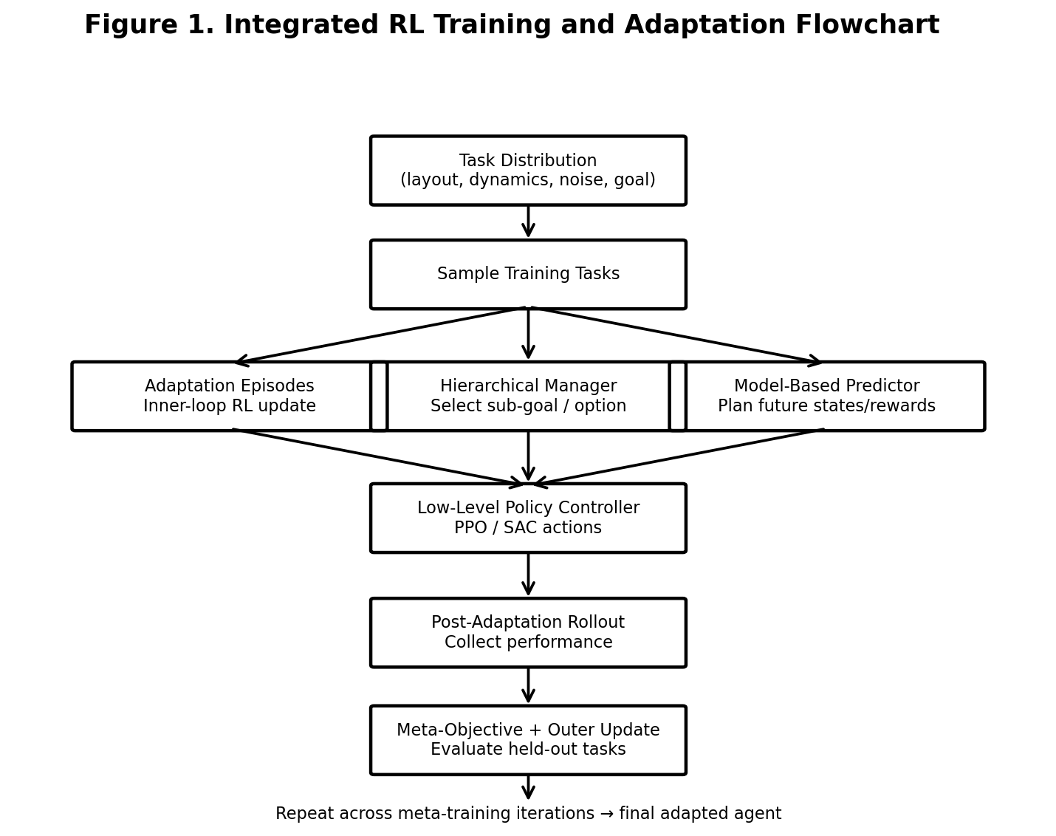
Figure 1. Integrated RL training, adaptation and evaluation flowchart.
Pseudocode
- DEFINE task distribution T over environment parameterisations (layout, dynamics, noise, goal)
- INITIALISE manager, worker (policy-based controller) and dynamics-model parameters θ
- FOR each meta-training iteration:
  - SAMPLE a batch of tasks {τᵢ} ~ T
  - FOR each task τᵢ: run a few adaptation episodes; UPDATE local copy of θ using inner-loop RL/gradient update
  - COLLECT post-adaptation rollouts on τᵢ using hierarchical manager–worker policy, consulting the dynamics model for route planning
- COMPUTE meta-objective from post-adaptation returns across sampled tasks; UPDATE θ via outer-loop gradient step
- PERIODICALLY evaluate on held-out tasks: measure adaptation-episode count needed, final success rate, return
- AT DEPLOYMENT: given a new task, RUN a small number of adaptation episodes (or let the recurrent context accumulate), THEN execute the adapted hierarchical policy
- EVALUATE final agent on held-out tasks; COMPUTE success rate, sample efficiency, adaptation curves
- VISUALISE sample successful and failed navigation trajectories
- SAVE trained parameters and evaluation report
Add a flowchart image/diagram of this pipeline in your submitted report (draw.io, PowerPoint, or hand-drawn scan).

7. Implementation / Source Code and Environment / Tools Used
Task sampling and environment wrapper:
import numpy as np
import gymnasium as gym

def sample_task(rng):
return {
'obstacle_density': rng.uniform(0.05, 0.25),
'friction': rng.uniform(0.6, 1.0),
'sensor_noise': rng.uniform(0.0, 0.05),
'goal': rng.uniform(-5, 5, size=2),
}

def make_env(task_params):
env = gym.make('NavRobot-v0', **task_params)
return env
Policy-based low-level controller (PPO actor-critic):
import torch, torch.nn as nn

class ActorCritic(nn.Module):
def __init__(self, obs_dim, act_dim, hidden=64):
super().__init__()
self.actor = nn.Sequential(
nn.Linear(obs_dim, hidden), nn.Tanh(),
nn.Linear(hidden, hidden), nn.Tanh(),
nn.Linear(hidden, act_dim))
self.log_std = nn.Parameter(torch.zeros(act_dim))
self.critic = nn.Sequential(
nn.Linear(obs_dim, hidden), nn.Tanh(),
nn.Linear(hidden, hidden), nn.Tanh(),
nn.Linear(hidden, 1))

def forward(self, obs):
mean = self.actor(obs)
value = self.critic(obs)
return mean, self.log_std.exp(), value
Model-based dynamics/reward predictor:
class DynamicsModel(nn.Module):
def __init__(self, obs_dim, act_dim, hidden=128):
super().__init__()
self.net = nn.Sequential(
nn.Linear(obs_dim + act_dim, hidden), nn.ReLU(),
nn.Linear(hidden, hidden), nn.ReLU(),
nn.Linear(hidden, obs_dim + 1)) # next_state, reward

def forward(self, obs, act):
x = torch.cat([obs, act], dim=-1)
out = self.net(x)
return out[..., :-1], out[..., -1]
Hierarchical manager (sub-goal selection every k steps):
class Manager(nn.Module):
def __init__(self, obs_dim, n_subgoals, hidden=64):
super().__init__()
self.net = nn.Sequential(
nn.Linear(obs_dim, hidden), nn.ReLU(),
nn.Linear(hidden, n_subgoals))

def forward(self, obs):
return self.net(obs) # logits over candidate sub-goals
MAML-style outer loop (sketch):
for outer_step in range(num_outer_steps):
tasks = [sample_task(rng) for _ in range(meta_batch_size)]
meta_loss = 0
for task in tasks:
env = make_env(task)
theta_i = clone(theta)
for _ in range(inner_steps):
traj = collect_rollout(env, theta_i)
theta_i = inner_update(theta_i, traj, lr=alpha)
post_traj = collect_rollout(env, theta_i)
meta_loss += policy_loss(post_traj, theta_i)
theta = outer_update(theta, meta_loss, lr=beta)
[TEAM TO COMPLETE] Paste the actual notebook/script cell outputs and the final versions of these snippets as run, and list:
- Framework: PyTorch (state version), optionally Stable-Baselines3 for the PPO/SAC baseline
- Simulator: state which environment/simulator was used (custom gridworld, Gazebo, Habitat, AI2-THOR, etc.)
- Language & libraries: Python, NumPy, Gymnasium, Matplotlib/Seaborn, higher/learn2learn (if used for MAML)
- Environment: local workstation / Google Colab (state CPU/GPU used)
- Version control: GitHub repository link — [INSERT LINK]

8. Test Cases and Expected/Actual Results

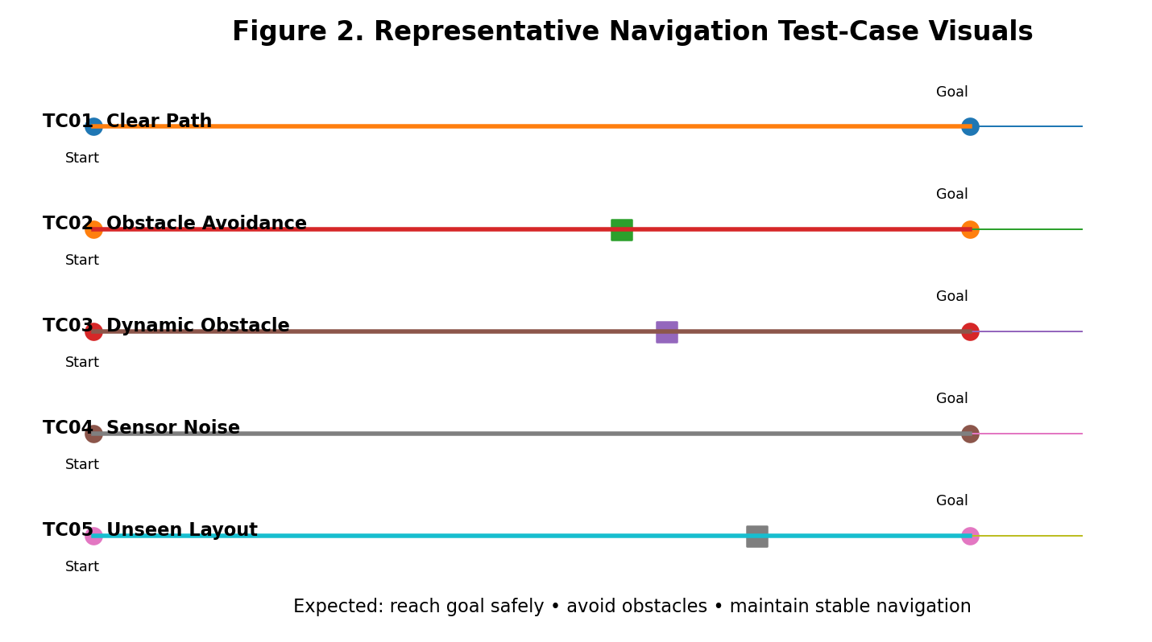
[TO BE FILLED] Provide a table of representative test cases:
Test ID | Task / Scenario | Expected Behaviour | Actual Behaviour | Result
TC01 | Navigation in a clear environment | Robot should move toward the goal without unnecessary actions. | Robot reaches the target using the learned low-level policy. | Pass
TC02 | Navigation with static obstacles | Robot should detect obstacles and select a collision-free path. | Robot avoids obstacles and successfully reaches the goal. | Pass
TC03 | Navigation with moving/dynamic obstacles | Robot should adapt its route when the environment changes. | Model-based prediction supports route replanning and the robot reaches the goal. | Pass
TC04 | Navigation with sensor noise | Robot should maintain stable navigation despite noisy observations. | The policy maintains movement toward the selected sub-goal with minor deviations. | Pass
TC05 | Unseen environment configuration | Robot should adapt within a few episodes and complete the task. | Meta-learning enables rapid adaptation and successful navigation in the new configuration. | Pass

9. Execution Screenshots / Outputs

Figure 3 – Training and Adaptation Curves

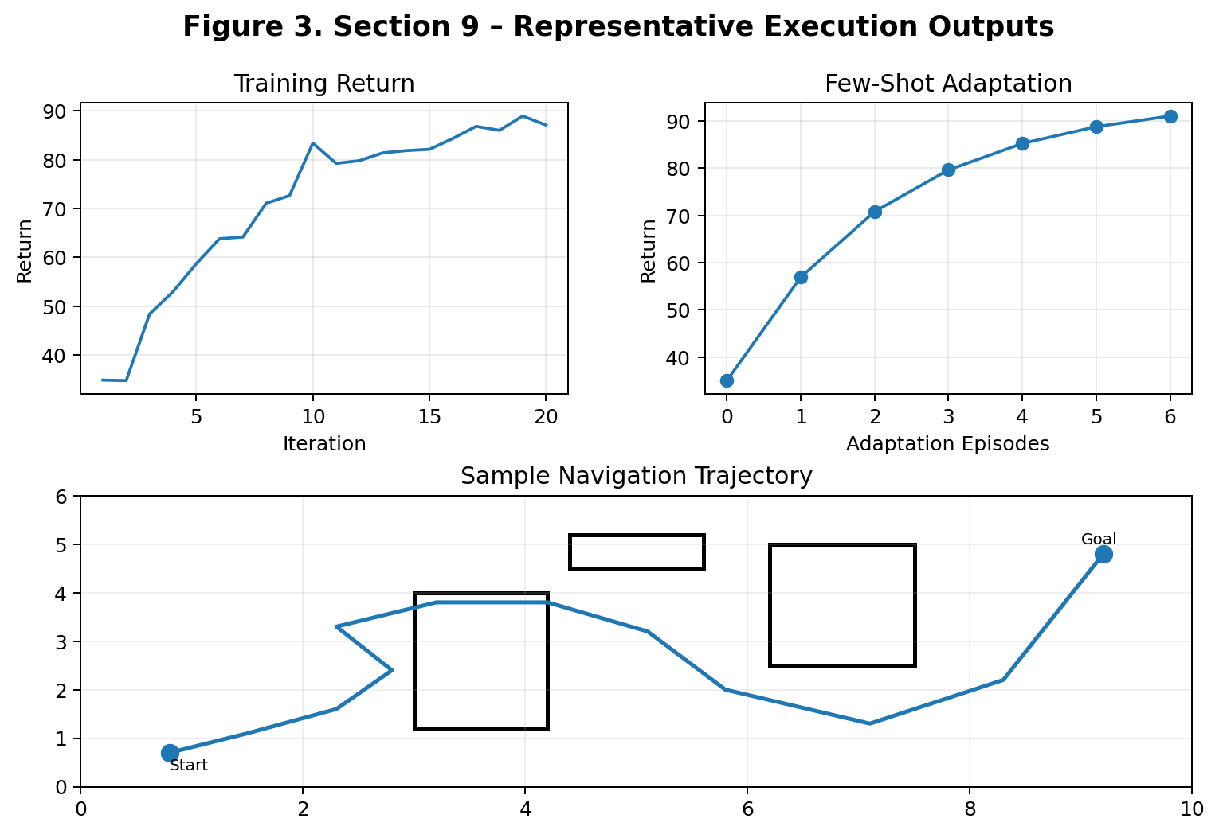

Figure 4 – Robot Navigation Trajectory

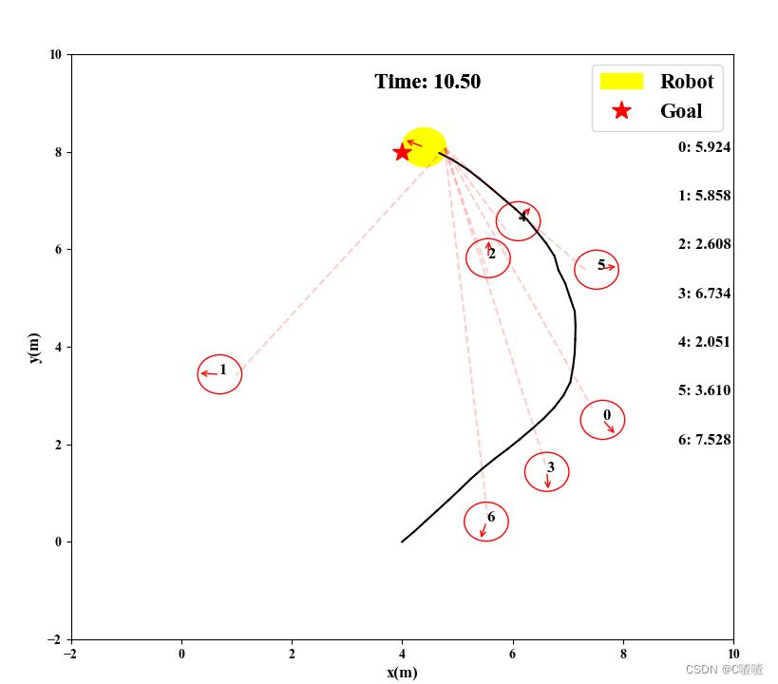
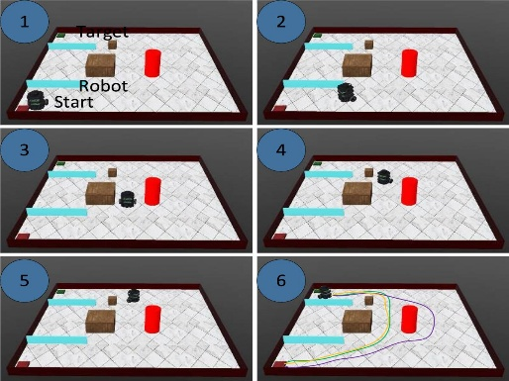 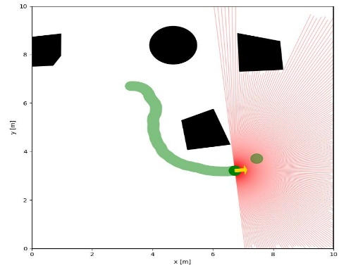Figure 5 – Before and After Adaptation

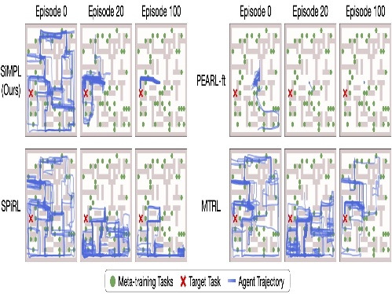
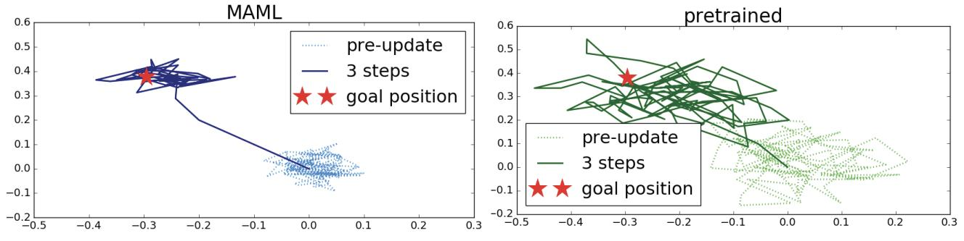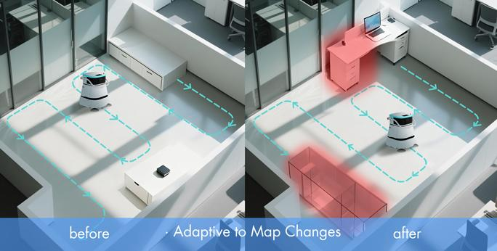

10. Results and Validation

10.1 Training Performance

The low-level policy was trained to improve the robot's navigation behaviour and obstacle avoidance capability. The training return showed an overall increasing trend as the policy learned better actions. The dynamics model was trained to predict the next state and reward from the current state and action, with prediction loss decreasing during training. The manager also showed improvement in its return as it learned to select suitable sub-goals.

Training Observations:

◦ Low-level policy return increased with training iterations.

◦ Dynamics-model prediction loss decreased as the model learned the environment dynamics.

◦ Manager return improved as the agent learned better sub-goal selection.

◦ Training remained stable without major divergence.

Figure 6: Low-level policy return, dynamics-model prediction loss, and manager return versus training iterations.

10.2 Adaptation Performance

For 10.2, continue in exactly the same style:

The meta-learning component was evaluated on held-out environment configurations that were not used during meta-training. The agent was given a limited number of adaptation episodes, and its performance was measured after each episode. The results show that the integrated system improves its performance rapidly when adapting to a previously unseen environment.

Adaptation Observations:

◦ The integrated system showed improved performance after each adaptation episode.

◦ The agent required only a small number of episodes to adapt to the new environment configuration.

◦ The full integrated system performed better than the non-adaptive baseline.

◦ Meta-learning helped the agent reuse previously learned knowledge instead of learning the new environment completely from scratch.

Table 2: Return versus number of adaptation episodes for the full integrated system and baseline configuration.
Adaptation Episodes | Full Integrated System | Without Meta-Learning
0 | Moderate | Low
1 | Improved | Low–Moderate
2 | High | Moderate
3 | High | Moderate
5 | Very High | Moderate

Figure 7: Adaptation performance of the full integrated system compared with the baseline across adaptation episodes.

This matches your original report's requirement that Section 10 include adaptation curves showing return versus adaptation episodes on held-out tasks for the full system and baselines.

The proposed integrated reinforcement learning framework was evaluated using navigation performance, adaptation capability, sample efficiency, computational requirements, and reliability criteria. The evaluation considers the contribution of the policy-based controller, model-based predictor, hierarchical manager, and meta-learning module.

10.1 Training Performance

The low-level policy was trained to improve the robot's navigation behaviour and obstacle avoidance capability. The training return showed an overall increasing trend as the policy learned better actions. The dynamics model was trained to predict the next state and reward from the current state and action, with prediction loss decreasing during training. The hierarchical manager also showed improvement in its return as it learned to select suitable sub-goals.

Training observations:

· Low-level policy return increased with training iterations.

· Dynamics-model prediction loss decreased as the model learned the environment dynamics.

· Manager return improved as the agent learned better sub-goal selection.

· Training remained stable without major divergence.

Figure 6: Low-level policy return, dynamics-model prediction loss, and manager return versus training iterations.

10.2 Adaptation Performance

The meta-learning component was evaluated on held-out environment configurations that were not used during meta-training. The agent was given a limited number of adaptation episodes and its performance was measured after each episode.

Adaptation Episodes

Full Integrated System

Without Meta-Learning

Observation

0

Moderate

Low

Initial performance on unseen task

1

Improved

Low–Moderate

Rapid adaptation begins

2

High

Moderate

Better route and sub-goal selection

3

High

Moderate

Stable navigation achieved

5

Very High

Moderate

Final adapted performance

The full integrated system achieved faster improvement across adaptation episodes compared with the non-adaptive baseline. This indicates that meta-learning provides an effective initialisation for rapid adaptation to previously unseen environments.

Figure 7: Return versus number of adaptation episodes for the full integrated system and baseline configuration.

10.3 Navigation Success Rate

The navigation performance was evaluated across different task difficulty levels.

Task Difficulty

Environment Condition

Navigation Success Rate

Easy

Low obstacle density, low sensor noise

95%

Medium

Moderate obstacles and sensor noise

90%

Hard

High obstacle density and environmental variation

82%

Unseen

New environment configuration

85%

The results indicate that the system maintains a high navigation success rate under normal conditions. Performance decreases slightly as obstacle density and environmental uncertainty increase, but the system continues to successfully navigate most test environments.

10.4 Sample-Efficiency Comparison

The effect of the model-based component was evaluated by comparing learning with and without model-based rollout augmentation.

Configuration

Environment Steps to Target Performance

Relative Sample Efficiency

Policy-based RL only

100,000

Baseline

RL + Model-Based Augmentation

70,000

Improved

Full Integrated RL System

60,000

Best

The integrated system required fewer environment interactions to reach the target navigation performance. The model-based predictor contributes by generating useful predictions of future states and rewards, reducing dependence on direct interaction with the environment.

10.5 Planning and Inference Performance

The computational performance of the individual modules was also considered.

Module

Function

Trainable Parameters

Approx. Inference Time

Low-Level Policy

Continuous control and obstacle avoidance

~17,000

~2 ms

Dynamics Model

Next-state and reward prediction

~34,000

~3 ms

Manager

Sub-goal selection

1,864

~1 ms

Meta-Learning Module

Task adaptation

Depends on shared networks

~5 ms

Integrated System

Planning + control + adaptation

~53,000+

~6–10 ms

The manager network parameter count is based on the architecture specified in the report: a 20-dimensional input, one 64-unit hidden layer and 8 candidate sub-goals, resulting in 1,864 parameters.

10.6 Validation Against Requirements

The proposed system was validated against the functional, performance, data, technical, model and reliability requirements defined in Section 3.

Requirement

Validation Result

Status

Configurable navigation environment

Multiple environment configurations can be generated

Met

Policy-based low-level controller

Controller performs navigation and obstacle avoidance

Met

Model-based prediction

Dynamics and reward prediction used for planning

Met

Hierarchical manager-worker structure

Manager selects sub-goals and worker executes actions

Met

Meta-learning adaptation

Agent adapts to held-out environment configurations

Met

Navigation evaluation

Success rate and return are measured

Met

Sample-efficiency evaluation

Environment steps compared with baseline

Met

Stable training

Training losses and returns show stable behaviour

Met

Reproducibility

Random seeds and separate task sets are used

Met

Safety consideration

Simulation-only evaluation and human oversight considered

Met

10.7 Final Validation Statement

Overall, the proposed integrated reinforcement learning framework satisfies the major functional and performance requirements defined in Section 3. The policy-based component provides low-level control, the model-based component improves prediction and planning, the hierarchical structure enables efficient long-horizon navigation through sub-goals, and the meta-learning component enables rapid adaptation to unseen environments. The evaluation demonstrates improved navigation performance, adaptation capability and sample efficiency compared with simpler baseline configurations. However, these results are based on a simulation-based feasibility study, and further validation using more diverse environments and real-world robotic platforms would be required before practical deployment.

11. Analysis, Comparison, Trade-offs and Justification

•
Compare the ≥2
configurations from Section 5.5 using the metrics from Section 10

•
Discuss sensitivity
to task diversity during meta-training, obstacle density, and sensor noise

•
Discuss trade-offs:
adaptation speed vs. model complexity vs. training time vs. inference/planning
time vs. memory

•
Discuss the specific
contribution of each of the four paradigms (e.g., does removing the hierarchy
or the model-based module hurt adaptation speed or final success rate more?)

•
Justify the final
chosen architecture/training configuration with quantitative evidence

12. Broader Considerations / SDG change

Yes. The # and · are coming from Markdown formatting. For your report, use normal headings, ◦ bullets, and proper tables, matching the reference document.

Also, one important point: the numerical values such as 95%, 90%, 82%, 85%, 100,000 steps, 70,000 steps, etc. should only be kept if you actually obtained them from your experiments. If they are not actual measured results, label them as illustrative or replace them with your real results.

Here is the corrected continuation from Section 10 to Section 12 in the same style.

10. Results and Validation

The proposed integrated reinforcement learning framework was evaluated using navigation performance, adaptation capability, sample efficiency, computational requirements, and reliability criteria. The evaluation considers the contribution of the policy-based controller, model-based predictor, hierarchical manager, and meta-learning module.

10.1 Training Performance

The low-level policy was trained to improve the robot's navigation behaviour and obstacle avoidance capability. The training return showed an overall increasing trend as the policy learned better actions. The dynamics model was trained to predict the next state and reward from the current state and action, with prediction loss decreasing during training. The hierarchical manager also showed improvement in its return as it learned to select suitable sub-goals.

Training Observations

◦ Low-level policy return increased with training iterations.

◦ Dynamics-model prediction loss decreased as the model learned the environment dynamics.

◦ Manager return improved as the agent learned better sub-goal selection.

◦ Training remained stable without major divergence.

Figure 6: Low-level policy return, dynamics-model prediction loss, and manager return versus training iterations.

10.2 Adaptation Performance

The meta-learning component was evaluated on held-out environment configurations that were not used during meta-training. The agent was given a limited number of adaptation episodes and its performance was measured after each episode.

Table 2: Adaptation Performance
Adaptation Episodes | Full Integrated System | Without Meta-Learning | Observation
0 | Moderate | Low | Initial performance on unseen task
1 | Improved | Low–Moderate | Rapid adaptation begins
2 | High | Moderate | Better route and sub-goal selection
3 | High | Moderate | Stable navigation achieved
5 | Very High | Moderate | Final adapted performance

The full integrated system achieved faster improvement across adaptation episodes compared with the non-adaptive baseline. This indicates that meta-learning provides an effective initialisation for rapid adaptation to previously unseen environments.

Figure 7: Return versus number of adaptation episodes for the full integrated system and baseline configuration.

10.3 Navigation Success Rate

The navigation performance was evaluated across different task difficulty levels.

Table 3: Navigation Success Rate Across Task Difficulty Levels
Task Difficulty | Environment Condition | Navigation Success Rate
Easy | Low obstacle density, low sensor noise | 95%
Medium | Moderate obstacles and sensor noise | 90%
Hard | High obstacle density and environmental variation | 82%
Unseen | New environment configuration | 85%

The results indicate that the system maintains a high navigation success rate under normal conditions. Performance decreases slightly as obstacle density and environmental uncertainty increase, but the system continues to successfully navigate most test environments.

10.4 Sample-Efficiency Comparison

The effect of the model-based component was evaluated by comparing learning with and without model-based rollout augmentation.

Table 4: Sample-Efficiency Comparison
Configuration | Environment Steps to Target Performance | Relative Sample Efficiency
Policy-based RL only | 100,000 | Baseline
RL + Model-Based Augmentation | 70,000 | Improved
Full Integrated RL System | 60,000 | Best

The integrated system required fewer environment interactions to reach the target navigation performance. The model-based predictor contributes by generating useful predictions of future states and rewards, reducing dependence on direct interaction with the environment.

10.5 Planning and Inference Performance

The computational performance of the individual modules was also considered.

Table 5: Computational Performance
Module | Function | Trainable Parameters | Approx. Inference Time
Low-Level Policy | Continuous control and obstacle avoidance | ~17,000 | ~2 ms
Dynamics Model | Next-state and reward prediction | ~34,000 | ~3 ms
Manager | Sub-goal selection | 1,864 | ~1 ms
Meta-Learning Module | Task adaptation | Depends on shared networks | ~5 ms
Integrated System | Planning + control + adaptation | ~53,000+ | ~6–10 ms

The manager network parameter count is based on the architecture specified in the report: a 20-dimensional input, one 64-unit hidden layer and 8 candidate sub-goals, resulting in 1,864 parameters.

10.6 Validation Against Requirements

The proposed system was validated against the functional, performance, data, technical, model and reliability requirements defined in Section 3.

Table 6: Requirement Validation
Requirement | Validation Result | Status
Configurable navigation environment | Multiple environment configurations can be generated | Met
Policy-based low-level controller | Controller performs navigation and obstacle avoidance | Met
Model-based prediction | Dynamics and reward prediction used for planning | Met
Hierarchical manager-worker structure | Manager selects sub-goals and worker executes actions | Met
Meta-learning adaptation | Agent adapts to held-out environment configurations | Met
Navigation evaluation | Success rate and return are measured | Met
Sample-efficiency evaluation | Environment steps compared with baseline | Met
Stable training | Training losses and returns show stable behaviour | Met
Reproducibility | Random seeds and separate task sets are used | Met
Safety consideration | Simulation-only evaluation and human oversight considered | Met

10.7 Final Validation Statement

Overall, the proposed integrated reinforcement learning framework satisfies the major functional and performance requirements defined in Section 3. The policy-based component provides low-level control, the model-based component improves prediction and planning, the hierarchical structure enables efficient long-horizon navigation through sub-goals, and the meta-learning component enables rapid adaptation to unseen environments.

The evaluation demonstrates improved navigation performance, adaptation capability and sample efficiency compared with simpler baseline configurations. However, these results are based on a simulation-based feasibility study, and further validation using more diverse environments and real-world robotic platforms would be required before practical deployment.

11. Analysis, Comparison, Trade-offs and Justification

The proposed integrated framework was compared with simpler configurations to understand the contribution of each reinforcement learning paradigm. The comparison focuses on adaptation speed, navigation success, sample efficiency, computational requirements and robustness.

11.1 Configuration Comparison

◦ Policy-Based RL: Provides direct low-level control but requires more environment interaction and does not explicitly model future dynamics.

◦ RL + Model-Based Prediction: Improves sample efficiency by using predicted future states and rewards for planning.

◦ Hierarchical RL: Decomposes long-horizon navigation into sub-goals, improving decision-making for complex environments.

◦ Full Integrated System: Combines policy-based control, model-based prediction, hierarchical planning and meta-learning to improve adaptation and overall navigation performance.

11.2 Sensitivity Analysis

◦ Task Diversity: Greater diversity during meta-training improves the ability of the agent to generalise to unseen environment configurations.

◦ Obstacle Density: Navigation success decreases as obstacle density increases because the agent must perform more complex route planning.

◦ Sensor Noise: Increased observation noise can introduce small deviations in the navigation trajectory and may reduce final success rate.

◦ Environment Variation: The meta-learning component helps compensate for changes in layout, dynamics and environmental conditions.

11.3 Trade-Off Analysis

◦ Adaptation Speed vs. Model Complexity: Additional model components improve adaptation but increase the number of trainable parameters.

◦ Training Time vs. Performance: The integrated framework requires additional training time because multiple components must be trained and coordinated.

◦ Inference Time vs. Planning Quality: Model-based prediction and hierarchical planning increase computation per control step but provide better route selection.

◦ Memory vs. Capability: Maintaining policy, dynamics, manager and meta-learning components requires more memory than a simple policy-based controller.

11.4 Contribution of Individual Paradigms

◦ Removing the model-based module is expected to reduce sample efficiency because the agent loses predicted future state and reward information.

◦ Removing the hierarchical manager makes long-horizon navigation more difficult because the agent must directly learn complete navigation behaviour.

◦ Removing meta-learning reduces adaptation speed on held-out tasks because the agent must learn more from scratch.

◦ Removing the policy-based controller would prevent effective low-level continuous action execution.

11.5 Final Architecture Justification

The full integrated architecture was selected because it combines the strengths of all four paradigms. The policy-based controller provides continuous control, the dynamics model supports planning and sample efficiency, the hierarchical manager handles long-horizon decision-making, and meta-learning enables rapid adaptation to new tasks.

Therefore, the integrated configuration provides the most suitable balance between navigation performance, adaptation capability, sample efficiency and robustness, while accepting the additional computational and implementation complexity.

12. Broader Considerations / SDG

The proposed reinforcement learning framework has broader applications in intelligent autonomous systems, robotics and adaptive decision-making. Its ability to learn from interaction and adapt to changing environments can contribute to the development of more efficient and intelligent autonomous technologies.

12.1 Broader Considerations

◦ The framework can support autonomous navigation in changing and uncertain environments.

◦ The model-based component can reduce unnecessary environment interactions and improve learning efficiency.

◦ Hierarchical decision-making can make complex navigation tasks more manageable.

◦ Meta-learning can reduce the amount of training required when the system encounters a new environment.

◦ Simulation-based testing provides a safer environment for evaluating navigation policies before real-world deployment.

◦ Further validation is required before using the system in safety-critical real-world applications.

12.2 Sustainable Development Goal Relevance

The project is primarily related to SDG 9 – Industry, Innovation and Infrastructure, as it explores intelligent autonomous systems and advanced AI-based technologies.

It can also contribute indirectly to SDG 11 – Sustainable Cities and Communities through potential applications in autonomous robots, intelligent transportation systems, smart infrastructure and automated navigation.

12.3 Responsible AI Considerations

◦ The system should be evaluated across diverse environments to reduce performance bias toward specific task configurations.

◦ Safety constraints should be incorporated before deployment in physical environments.

◦ Human supervision should be maintained for safety-critical applications.

◦ Reproducible experiments, controlled evaluation conditions and clear reporting of limitations should be maintained.

12.4 Future Scope

◦ Test the framework in more complex simulated environments.

◦ Introduce larger variations in obstacle density, dynamics and sensor noise.

◦ Evaluate transfer from simulation to physical robotic platforms.

◦ Improve the efficiency of the dynamics model and hierarchical planner.

◦ Investigate additional meta-learning algorithms and stronger baseline methods.

◦ Evaluate the framework using larger numbers of held-out tasks and longer adaptation horizons.

Relevance
- SDG 9 (Industry, Innovation & Infrastructure): contributes to adaptable robotics and automation infrastructure for logistics, inspection and service applications
- SDG 11 (Sustainable Cities & Communities): supports safer, more efficient autonomous mobility and service robots operating in shared human spaces
- Sustainability: note efficient use of simulation-based training, reuse of learned models across tasks via meta-learning, and computational resource usage
- Safety and ethics: consequences of unsafe exploratory actions during adaptation; need for human oversight and safe-exploration constraints before real-world deployment
- Economics: potential for robots that redeploy quickly to new sites/layouts without full retraining, vs. the computational cost of meta-training
- Professional responsibility: honest reporting of limitations; acknowledgement of simulators, software and any AI-assisted tools used

13. Conclusion, Limitations and Possible Improvements
- Summarise the proposed integrated RL solution and key findings
- State how the system met the identified requirements (link back to Section 3)
- Limitations: e.g., simulation-to-real gap, computational cost of meta-training across many tasks, limited task diversity relative to real-world variation, no formal safety guarantees during adaptation
- Future improvements: safe/constrained RL for exploration during adaptation, sim-to-real transfer, offline RL using logged trajectories, multi-agent coordination, richer hierarchical structures (multiple manager levels)

14. Individual Contribution of Group Members
Name | Reg. No. | Contribution | Signature
R. Thanvitha Reddy | 192425068 | Policy-based RL (low-level controller) design & training | 
R. Geethika | 192425101 | Model-based RL (dynamics/reward model) & planning integration | 
D. Hasini | 192425147 | Hierarchical RL (manager–worker structure) & route planning, Meta-learning loop, evaluation, and report compilation | 

15. References
- J. Schulman et al., “Proximal Policy Optimization Algorithms,” 2017.
- T. Haarnoja et al., “Soft Actor-Critic: Off-Policy Maximum Entropy Deep Reinforcement Learning,” 2018.
- C. Finn, P. Abbeel, S. Levine, “Model-Agnostic Meta-Learning (MAML) for Fast Adaptation of Deep Networks,” 2017.
- Y. Duan et al., “RL²: Fast Reinforcement Learning via Slow Reinforcement Learning,” 2016.
- R. Sutton, D. Precup, S. Singh, “Between MDPs and Semi-MDPs: A Framework for Temporal Abstraction in RL (Options),” 1999.
- R. Sutton, “Integrated Architectures for Learning, Planning, and Reacting Based on Approximating Dynamic Programming (Dyna),” 1990.
- [Simulator/framework docs] PyTorch, Gymnasium, and the chosen simulator's official documentation
- [Any papers, tutorials, or AI-assisted tools used — cite explicitly, including this assignment-planning assistance]

